Luxury Boutique Style 9 Nights
Destinations
Lima Cusco Puno
- Travel itinerary
- Conditions - Terms
- Included
- Transfers in Lima and Cusco according to the itinerary.
- 2-night accommodation at Hotel B (2 breakfasts and tea time)
- 2-night accommodation at Aranwa Sacred Valley & Wellness (2 breakfasts)
- Learning with Racchi weavers (for children)
- 20 minutes of Reflexology
- Circuit of meditation
- Tour " Colonial Mansion and Furniture Collection" in Aranwa Valle
- River fishing
- Kite flying for kids
- FD Sacred Valley of the Incas (lunch at Wayra Ranch and Paso Horse Exhibition)

View more

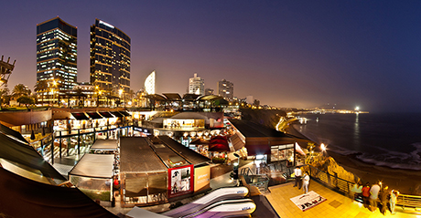

Day 1

Lima – Wednesday
Arrival in Lima, assistance, and transfer to the hotel. Enjoy the night in one of the most exclusive hotels in Lima, Hotel B Barranco, a place for contemporary explorers of life seeking the mysteries of Peruvian culture, geography, and nature. This hotel was originally built in the “Belle Époque“, its architectural features and flair capture the celebratory spirit of Peru’s centennial, which permeated life in the capital city throughout the era of its construction. Accommodation at Hotel B, Lima. Meals: None.

Day 2

Lima - Thursday
A day at leisure to make activities by your own. Accommodation at Hotel B, Lima. Meals: Breakfast

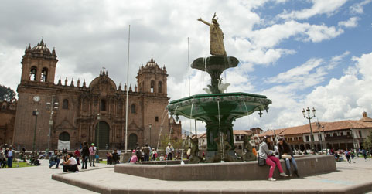
Day 3

Lima/Cusco/Sacred Valley – Friday
At according time transfer to the airport to take your flight to Cusco. At your arrival assistance and transfer to the Sacred Valley and directly to Aranwa Sacred Valley Wellness & Spa. Today you will enjoy the “Unno Spa”, the most complete and specialized health center where mind, body, and spirit will be renewed. It has a modern infrastructure that includes everything from a hyperbaric chamber, hydrotherapy pools, and Vichy shower treatment. Accommodation at Aranwa Sacred Valley Wellness & Spa. Meals: Breakfast

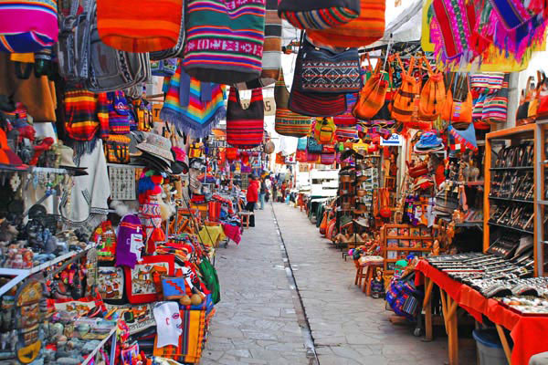

Day 4

Sacred Valley - Saturday
Visit the Sacred Valley, a picturesque tour where you can see important archaeological remains, landscapes, and village customs. This tour begins with the first stop at Awanacancha Complex, here you can have the chance to feed Andean Camelids such as “llamas” and “alpacas”; also, you can have the opportunity to meet local people who will show their techniques for weaving in their local sites. The tour will include the visit of the typical Pisaq Market where you can have the opportunity to shop or buy local handicrafts and try the traditional local costumes. Then we will visit one of the best restaurants located in the Sacred Valley, the Wayra Ranch, here you will enjoy a delicious lunch and can see a beautiful display of Peruvian Paso Horse, known for their elegant and delicate walk. The show includes stylish Peruvian Horse Riders showing you an elegant exhibition. It´s important to mention that the Peruvian Paso Horse is a unique breed in the world because of the elegance and softness of its walk. In the afternoon, you will visit Ollantaytambo Fortress, made up by series of overlapped steps and terraces, built to protect the city from any invasion coming from the jungle through this part of the valley. You will have the opportunity to walk the narrow streets of the village and get a first-hand feeling of a military, religious and cultural center of the Inca Empire. Alojamiento en Aranwa Sacred Valley Wellness & Spa. Meals: Breakfast & Lunch.
Day 5

Sacred Valley/Machu Picchu/Cusco - Sunday
Live one of the most fascinating and extraordinary experiences of the world: Machu Picchu. The adventure begins by embarking on one of the most beautiful railway routes, pass through picturesque Andean landscapes and enjoy the amazing lush jungle until you arrive at the City of Aguas Calientes; here you´ll take the bus for a 30-minute drive along a zigzagging path leading to the marvelous citadel. Machu Picchu may have been home to Pachacutec, first Inca emperor. Walk through passageways and alleys of the Citadel enjoy and take in this unique place in the world. Take free time to enjoy the mystic energy and natural beauty of the site. At according time, you will enjoy a delicious lunch in the exclusive restaurant of the Sanctuary Lodge Hotel. Then you have the chance to return to the Citadel or go back to the Station of Aguas Calientes to take the train back to Cusco. At your arrival, you will be pleased to be transferred to Aranwa Cusco Boutique Hotel, a luxury and comfort hotel built in a colonial mansion of the XVI century. It displays several paintings of the Cuzcanian Art and colonial sculptures. The elegant rooms are equipped with intelligent oxygen system and heat floor for a great stay. Accommodation at Aranwa Cusco Boutique Hotel. Meals: Breakfast and lunch.

Day 6

Cusco – Free Day - Monday
A day at leisure to rest or make activities of your interest. Accommodation at Aranwa Cusco Boutique Hotel. Meals: Breakfast and dinner.

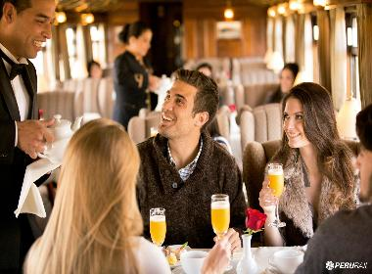

Day 7

Cusco/ Puno (Spirit Of The Water) – Tuesday
Take the train in Cusco, the ancient capital of the Inca Empire. Settle into your private cabin, and take the time to relax in the complacent atmosphere of the train. Maybe approach the Observatory Car, ask for a classic Pisco Sour and see how the landscape unfolds. Later, take a seat in one of the two sophisticated dining cars for a delicious lunch. Refined Andean specialties are served with contemporary style. As the afternoon progresses, disembark for an excursion to Raqch“i. Formerly a defensive fortress of the Inca Empire, today it is a captivating archaeological site full of history. Return to the train for afternoon tea while continuing your journey southeast. Enjoy a picturesque sunset framed by the majestic mountains of La Raya. As the train continues to the Lake Titicaca station, enjoy a delicious dinner on board. Complete your evening in the Car Lounge and share stories with your fellow travelers before retiring to the comfort of your cabin. Meals: Breakfast, lunch, tea time, cocktail, dinner
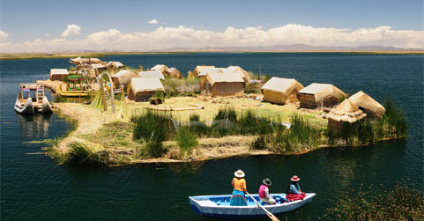

Day 8

Puno - Titilaka - Wednesday
Wake up early and enjoy a spectacular scene as the sun rises across Lake Titicaca. Breakfast is served on board. After a wonderful night trip, say goodbye to the crew and get ready to be transferred to Hotel Titilaka. On arrival at the lodge, check-in, rest, and enjoy the scenery. Lunch, based on the local cuisine, is served from 12:30pm to 3:00pm. We recommend an afternoon siesta and drinking plenty of liquids to help you acclimate. Enjoy teatime at 3:00pm, followed by activities near the lodge in the afternoon. Explore the lake and paddle through nearby totora reeds as you choose from a selection of nautical activities, including kayaking, canoeing, paddle-boarding, and sailing. Or, if you prefer, ride a bicycle through the fields of the district of Platería, take a walk on country paths, or watch local birds and drink in Puno’s striking landscapes. Evening cocktails are served from 6:30pm, followed by dinner and the gathering with other guests and interpreters to share experiences and tales of the highlands. Accomodation in Titilaka hotel, Puno Meals: Breakfast, lunch, tea time, cocktail, dinner
Day 9

Uros And Taquile Islands - Thursday
This is an active day. If you wish, get up at dawn to witness a magnificent sunrise. Whenever you do wake, enjoy a healthy breakfast in bed or on our terrace. In the morning, your guides will take you by car and boat to visit the famed Uros floating islands, near the Titicaca National Reserve. Here you will meet one of the traditional families that inhabit these unique islands. The Uro-Aymara people are a proud culture, where the men skillfully traverse the lake with rafts made from reeds, and the women are expert weavers. Calling themselves kot-suña or, “people of the lake,” the Uro-Aymara were once persecuted by other groups and forced to relocate to Lake Titicaca where they found refuge by creating the islands out of totora reeds. Considering themselves guardians of Titicaca, the Uro-Aymara claim to have black blood that supposedly makes them impervious to the cold. A must for travelers to the area, expect to see many visitors here. You will then explore Quechua beliefs and culture through the rich weaving tradition on the island of Taquile. Declared a part of UNESCO’s Masterpieces of the Oral and Intangible Heritage of Humanity, Taquile’s vivid textiles convey complex messages about the wearer’s social status and life. As the island enjoys a privileged microclimate, you’ll likely see men weaving wonderful pieces outdoors. You will then enjoy a picnic against the stunning backdrop of Titicaca’s deep blue skies, the lake’s sapphire waters, and on the horizon, Bolivia’s Cordillera Real, or Royal Mountain Range. Return to the hotel around 5:30pm and enjoy cocktails from 6:30pm and an á la carte dinner around 7:30pm. Meals: Breakfast, picnic, cocktail, dinner
Day 10

Titilaka/Out - Friday
After breakfast, and depending on the timing of your departure, you may enjoy a short excursion, an en route excursion, or your one of a range of activities near the lodge. The en-route excursion involves a visit to the mysterious, ancient site of Sillustani, home to the area’s best preserved chullpas, or funerary towers. Once a burial ground for the Pucara, Tiahuanaco, and Ccolla pre-Inca cultures, and then the Incas themselves, Sillustani’s chullpas offer an ideal opportunity to compare the contrasting pre-Columbian architectonic styles. Symbolizing life and birth, these ancient tombs were used for chiefs and other dignitaries. Made of stones weighing up to six tons, the biggest tower took around 50 years to complete. Offering archaeology and history, in a stunning natural setting, Sillustani is an impressive site we strongly recommend you see. Farewell takes place at Juliaca airport as you head off to your next destination. Meals: Breakfast
Not included
- Air tickets, taxes, and surcharges.
- International or domestic border taxes.
- Meals and services not mentioned in the itinerary.
- Personal expenses.

General Conditions
- Prices per person in US dollars according to the type of accommodation chosen.
- The programs do not include air tickets and taxes; In addition, national and international departure taxes are at passenger´s expense.
- Extra expenses at the travel destinations are for the account of the passenger.
- Excursions and transfers are provided in shared or group service (SIB)
- Services in Spanish or English, for other languages please consult your travel advisor.
- The order of the excursions and the hours of services can vary.
- For adventure tours, medical expenses in case of accidents are not included.
- The schedules indicated in this itinerary are for reference only; the final schedules will be provided by the operations personnel of the visited city.
- If you require additional nights or optional tours, you should consult prices with your travel advisor.
- Rates subject to variation without prior notice depending on availability of spaces or rates change at the time of making reservations.
- Modifications and/or cancellations apply penalties plus administrative expenses according to CTM Tours sales policies.

- Children Policy:
- Children up to 2 years old do not pay services, they share the room and services with the parents (does not include extra bed, tickets or designated seat in the tours)
- Children from 3 to 8 years old apply at Child rate according to the policies of each hotel, in some cases can share the bed with the parents without additional charge, they are entitled to breakfast and designated seat in the tours.
- In most hotels, only a maximum of 1 child per room in the company of 2 adults is allowed.
- Children must carry a document certifying their age at the time of travel.

- Important Notices:
- Foreign passengers must carry passports, Andean Migration Card (TAM), and stay no longer than 60 days in the country for the exoneration of the IGV (Peruvian tax) in the accommodation services, otherwise, they must pay the corresponding difference of the IGV tax (18%) directly to the hotel.

